Moving Shadow 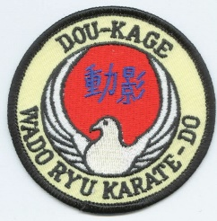Karate Club

TERM DATES AND HOLIDAY DATES 2022/2033

TERM DATES
Autumn term: 10th September to 17th December 2022
Spring term: 7th January to 25th March 2022
Summer term: 6th May to 22nd July 2022

HOLIDAY Closures 2022-2023
October Half term 29th October 2022
Xmas 24th&31st December 2022
February Half term 18th February 2023
Easter Holidays 7th & 4th April
Summer Half Term 3rd June 2022
Summer closure 29th July to 2nd September 2023

